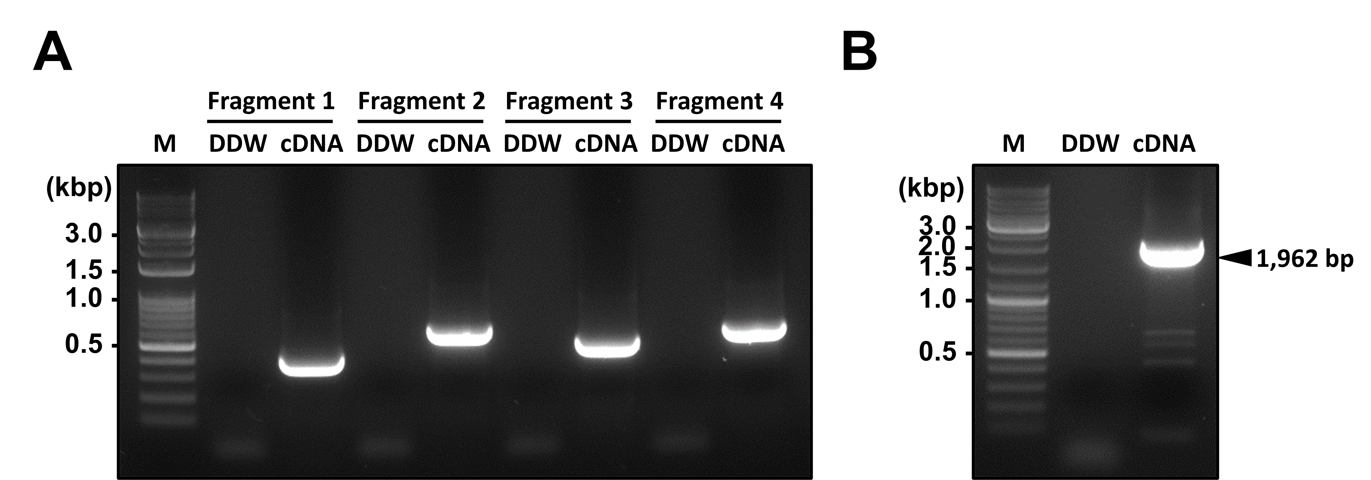
Supplementary Fig S1. Reverse transcription PCR for CsDAT segments and overlapping PCR for cDNA preparation. (A) The size of cDNA segments was expected 422 bp, 573 bp, 451 bp, and 637 bp that overlap with each segment for 15 bp. (B) The size of full-length of cDNA was expected 1,962 bp.

