Supplementary information
Evaluation of the antimalarial activity of SAM13-2HCl with morpholine amide (SKM13 derivative) against multiple antimalarial drug-resistant Plasmodium falciparum and Plasmodium berghei - infected ICR mice

Supplementary method
NMR of each candidate compound

Supplementary figures
Fig. S1. Raw data of IC₅₀s
Fig. S2. Raw data of PK
Fig. S3. Adsorption data

Supplementary method
All SAM series were prepared as HCl salts for further experiments and purified in MeOH and diethyl ether.
Synthesis of SAM09-2HCl and SAM11-2HCl
SAM09 and SAM11 were obtained by four steps: 1) a coupling reaction of Boc-Phe-OH and NHS by DCC, 2) an amide formation by reaction with a variety of amines, 3) Boc deprotection, and 4) a palladium coupling with 4,7-dichloroquinoline. SAM09 ¹H NMR (400 MHz, CDCl₃) δ 2.19 (s, 6H), 2.22-2.40 (m, 2H), 3.17-3.36 (m, 4H), 4.39-4.44 (m, 1H), 6.44 (d, 1H, NH, J = 5.6 Hz), 7.12-7.32 (m, 7H), 7.44 (dd, 1H, J = 8.3, 1.5 Hz), 7.78 (d, 1H, J = 2.2 Hz), 8.15 (d, 1H, J = 9.0 Hz), 8.33 (d, 1H, NH, J = 5.6 Hz). SAM11 ¹H NMR (500 MHz, CDCl₃) δ 1.04 (t, 6H, J = 7.0 Hz), 2.81 (q, 4H, J = 7.5 Hz), 2.84-3.01 (m, 2H), 3.27 (m, 2H), 3.45-3.64 (m, 2H), 4.31-4.39 (m, 1H), 6.34 (d, 1H, J = 5.5 Hz), 6.52 (brs, 1H, NH), 7.16-7.32 (m, 5H), 7.34 (dd, 1H, J = 8.5, 2.0 Hz), 7.84 (d, 1H, J = 9.5 Hz), 7.86 (d, 1H, J = 1.5 Hz), 8.39 (d, 1H, J = 6.0 Hz), 8.83 (brs, 1H, NH).
Synthesis of SAM10-2HCl ~ SAM17-HCl-TFA
SAM10, SAM12, SAM13 were obtained from 2-bromoethylamine hydrobromide, and SAM14-17 obtained from Fmoc-Gly-OH, which is described in Fig 1. Most important step was Horner-Wadsworth-Emmons reaction with 15 using DBU and LiCl for a mild condition.
SAM10-2HCl ¹H NMR (500 MHz, CD₃OD) δ) 1.00 (t, 6H, J = 7.5 Hz), 2.50-2.57 (m, 6H), 3.11-3.15 (m, 2H), 3.26-3.31 (m, 2H), 4.58-4.65 (m, 1H), 5.99 (dd, 1H, J = 15.0 , 1.5 Hz), 6.41 (d, 1H, J = 5.5 Hz), 6.83 (dd, 1H, J = 15.5, 5.0 Hz), 7.09-7.33 (m, 5H), 7.40 (dd, 1H, J = 9.5, 2.5 Hz) ,7.75 (d, 1H, J = 2.0 Hz), 8.17 (d, 1H, J = 9.5 Hz), 8.27 (d, 1H, J = 5.5 Hz).
SAM12-2HCl ¹H NMR (400 MHz, CD₃OD) δ 1.69-2.05(m, 6H), 2.89-3.02 (m, 2H), 3.14-3.36 (m, 4H), 3.51-3.73 (m, 4H), 4.88-5.01 (m, 1H), 6.21 (d, 1H, J = 15.6 Hz), 6.80 (d, 1H, J = 6.8 Hz), 6.94 (dd, 1H, J = 15.2, 5.2 Hz), 7.09-7.38 (m, 5H), 7.71 (dd, 1H, J = 9.2, 1.6 Hz), 7.86 (d, 1H, J = 2.0 Hz), 8.31 (d, 1H, J = 6.8 Hz), 8.55(d, 1H, J = 9.2 Hz), 8.97 (d, 1H, NH, J = 7.6 Hz).
SAM13-2HCl ¹H NMR (400 MHz, CD₃OD) δ 3.08-3.19 (m, 2H), 3.23-3.32 (m, 4H), 3.51-3.69 (m, 4H), 3.82 (t, 2H, J = 9.6 Hz), 3.97-4.08 (m, 2H), 4.98-5.06 (m, 1H), 6.23 (d, 1H, J = 15.6 Hz), 6.80 (d, 1H, J = 7.2 Hz), 6.94 (dd, 1H, J = 15.6, 5.6 Hz), 7.15-7.36 (m, 5H), 7.70 (dd, 1H, J = 9.2, 1.6 Hz), 7.86 (d, 1H, J = 2.0 Hz), 8.31 (d, 1H, J = 6.8 Hz), 8.55(d, 1H, J = 9.2 Hz).
SAM14-HCl ¹H NMR (400 MHz, CD₃OD) δ 3.15-3.31 (m, 2H), 3.92 (ABq, 2H, J = 16.8 Hz), 4.33-4.37 (m, 2H), 4.95-5.06 (m, 1H), 6.20 (dd, 1H, J = 15.6, 1.2 Hz), 6.76 (d, 1H, J = 7.2 Hz), 6.89 (dd, 1H, J = 10.0, 5.6 Hz), 7.10-7.36 (m, 11H), 7.70 (dd, 1H, J = 9.2, 1.6 Hz), 7.84 (d, 1H, J = 1.6 Hz), 8.28 (d, 1H, J = 7.2 Hz), 8.42 (brs, 1H, NH), 8.49 (d, 1H, J = 6.8 Hz).
SAM15-HCl ¹H NMR (400 MHz, CD₃OD) δ 0.90 (t, 3H, J = 7.2 Hz), 1.26-1.38 (m, 2H), 1.40-1.50 (m, 2H), 3.12-3.32 (m, 4H), 3.92 (ABq, 2H, J = 16.8 Hz), 4.95-5.05 (m, 1H), 6.19 (dd, 1H, J = 15.6, 2.0 Hz), 6.77 (d, 1H, J = 7.2 Hz), 6.90 (dd, 1H, J = 15.6, 5.6 Hz), 7.10-7.36 (m, 5H), 7.72 (dd, 1H, J = 9.2, 2.0 Hz), 7.84 (d, 1H, J = 2.0 Hz), 8.29 (d, 1H, J = 6.8 Hz), 8.47 (d, 1H, J = 7.6 Hz), 8.93 (d, 1H, NH, J = 8.0 Hz).
SAM16-HCl ¹H NMR (400 MHz, CD₃OD) δ 1.10 (d, 6H, J = 6.8 Hz), 3.16-3.26 (m, 2H), 3.83 (ABq, 2H, J = 18.0 Hz), 3.87-3.98 (m, 1H), 4.95-5.06 (m, 1H), 6.23 (d, 1H, J = 7.6 Hz), 6.78 (d, 1H, J = 6.8 Hz), 6.90 (dd, 1H, J = 15.6, 5.2 Hz), 7.08-7.36 (m, 5H), 7.70 (dd, 1H, J = 8.8, 1.6 Hz), 7.85 (d, 1H, J = 2.0 Hz), 8.29 (d, 1H, J = 6.4 Hz), 8.51 (d, 1H, J = 9.2 Hz), 8.95 (d, 1H, NH, J = 7.6 Hz).
16 ¹H NMR (400 MHz, CD₃OD) δ 1.47 (s, 9H), 3.18-3.32 (m, 2H), 3.35-3.56 (m, 8H), 3.78 (brs, 1H, NH), 4.12 (ABq, 2H, J = 17.2 Hz), 4.95-5.05 (m, 1H), 6.23 (dd, 1H, J = 15.2, 2.8 Hz), 6.77 (d, 1H, J = 7.2 Hz), 6.91 (dd, 1H, J = 15.6, 5.6 Hz), 7.12-7.35 (m, 5H), 7.72 (dd, 1H, J = 9.2, 2.0 Hz), 7.85 (d, 1H, J = 2.0 Hz), 8.29 (d, 1H, J = 7.2 Hz), 8.48 (d, 1H, J = 5.6 Hz), 8.92 (d, 1H, NH, J = 7.6 Hz).
SAM17-HCl-TFA ¹H NMR (400 MHz, CD₃OD) δ 3.14-3.34 (m, 6H), 3.77 (s, 4H), 4.14 (ABq, 2H, J = 17.2 Hz), 4.96-5.05 (m, 1H), 6.24 (dd, 1H, J = 15.6, 1.6 Hz), 6.77 (d, 1H, J = 7.6 Hz), 6.92 (dd, 1H, J = 15.6, 5.6 Hz), 7.08-7.35 (m, 5H), 7.72 (dd, 1H, J = 9.2, 2.4 Hz), 7.85 (d, 1H, J = 1.6 Hz), 8.29 (d, 1H, J = 7.2 Hz), 8.47 (d, 1H, J = 5.2 Hz).
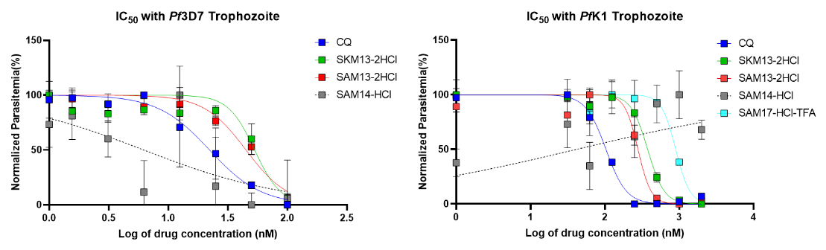
Fig.S1. Raw data of IC₅₀s
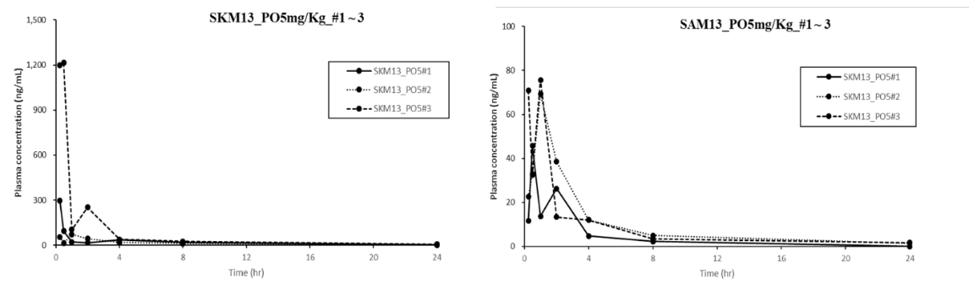
Fig.S2. Raw data of PK
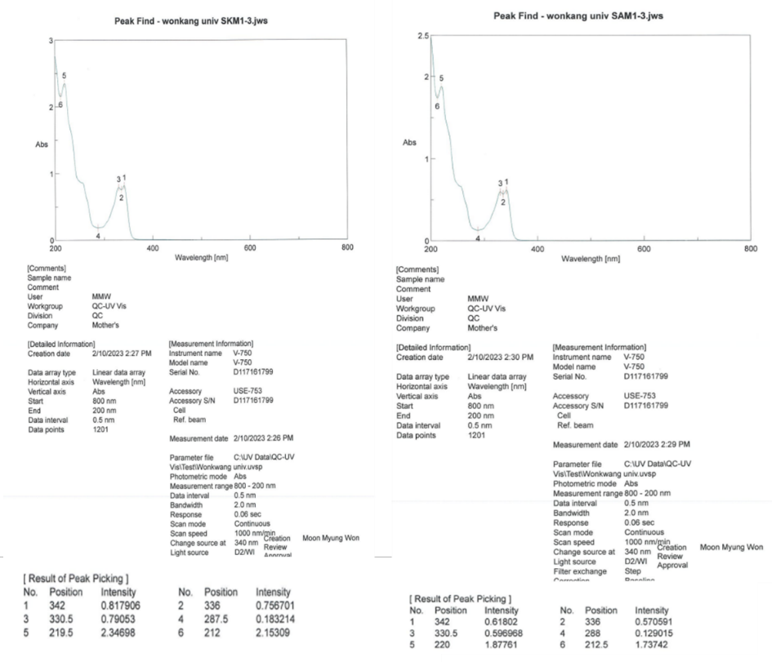
Fig. S3. Adsorption data

